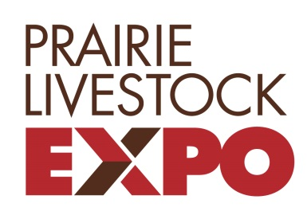
Prairie Livestock Expo 2018

DEADLINE FOR APPLICATIONS & PAYMENT:
Friday November 23, 2018
FEE:
$70 PER HOG
ENTERED
Pork Quality Competition
Entry Form

Entry Details:
  - Mail or Hand Deliver entry form to:
    - Manitoba Pork Council – 28 Terracon Place, Winnipeg MB, R2J 4G7
  - Make Cheques Payable to: “Prairie Livestock Expo”
  - Limit: Maximum of two (2) market hogs per sow operation (ex. New Haven North can enter 2 hogs & New Haven South can enter 2 hogs)
  - All hogs must have originated and been in the OWNERSHIP of the entrant’s farm for at least 65 days prior to December 1, 2018.
OPERATION NAME: _______________________________________________

ADDRESS: ______________________________________________________

CONTACT: __________________________ PHONE #: ___________________

Number of hogs entered: 1 or 2

Charitable Organization Information:

- 50% of the Prize Money will be donated to a maximum of two charitable organizations
- Note: If you leave this section blank, the Committee will assign a charity for you.

(1) Name of Charitable Organization: ______________________________________
Address:___________________________________ Tel:________________________

(2) Name of Charitable Organization: ______________________________________
Address:___________________________________ Tel:________________________

Do you wish to donate the other 50% of your potential prize money? YES:___ NO:___

(3) Name of Charitable Organization (Additional 50%): ________________________
Address:___________________________________ Tel:________________________

* Entry Fee is due with application form by November 23, 2018 *
Please Contact Darren Bates with any questions – C: (204) 799-8888

